Original Home Page:
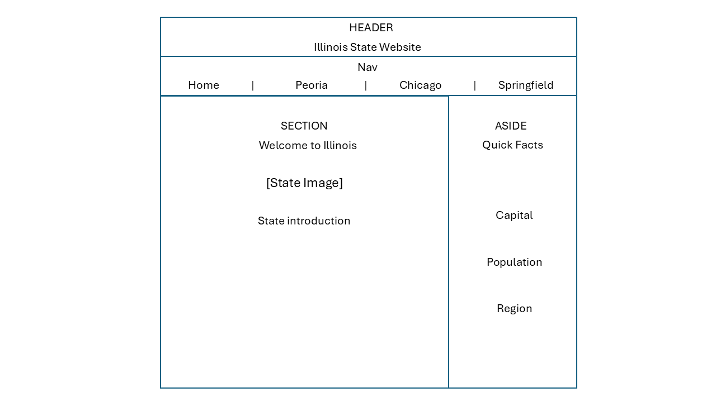

Original Interior Page:
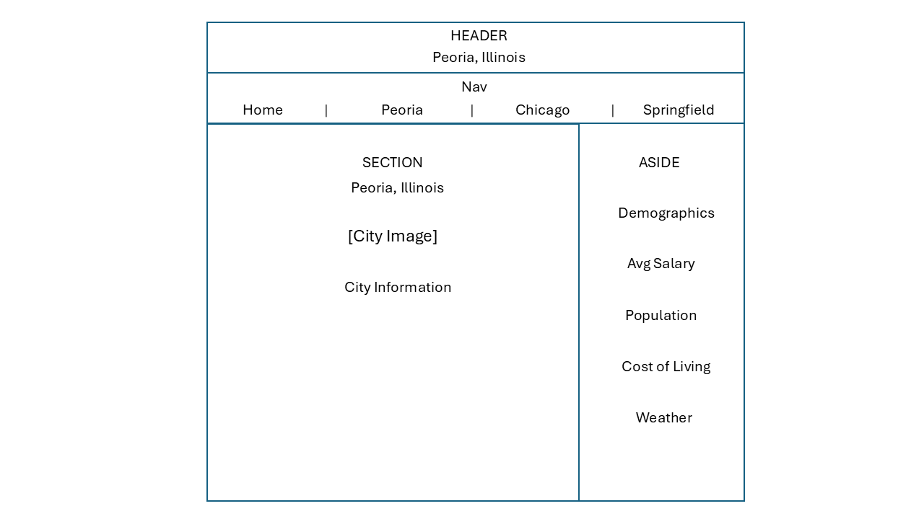
Final Home Page Layout:
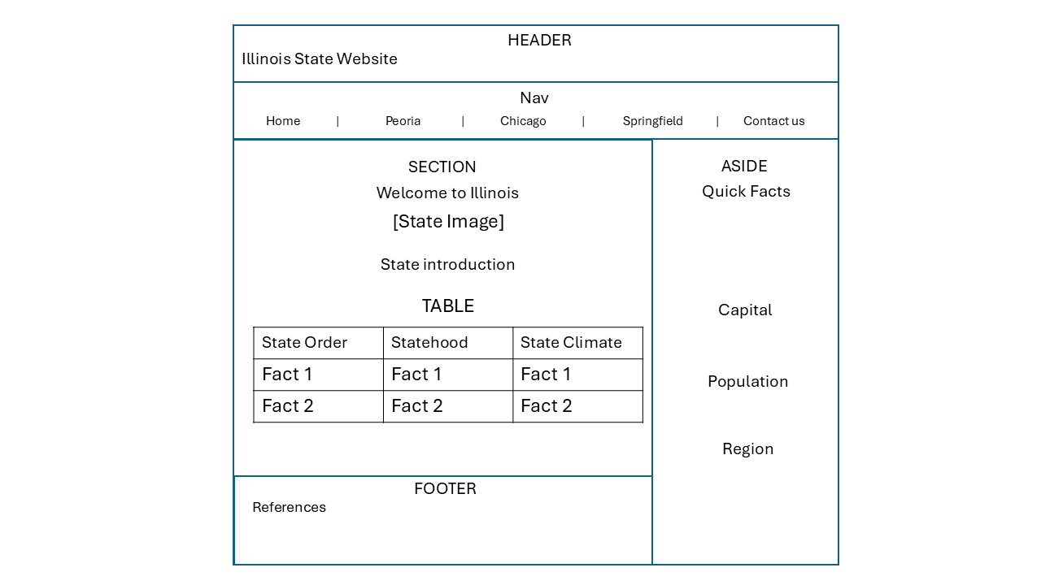

Final Interior Page Layout:
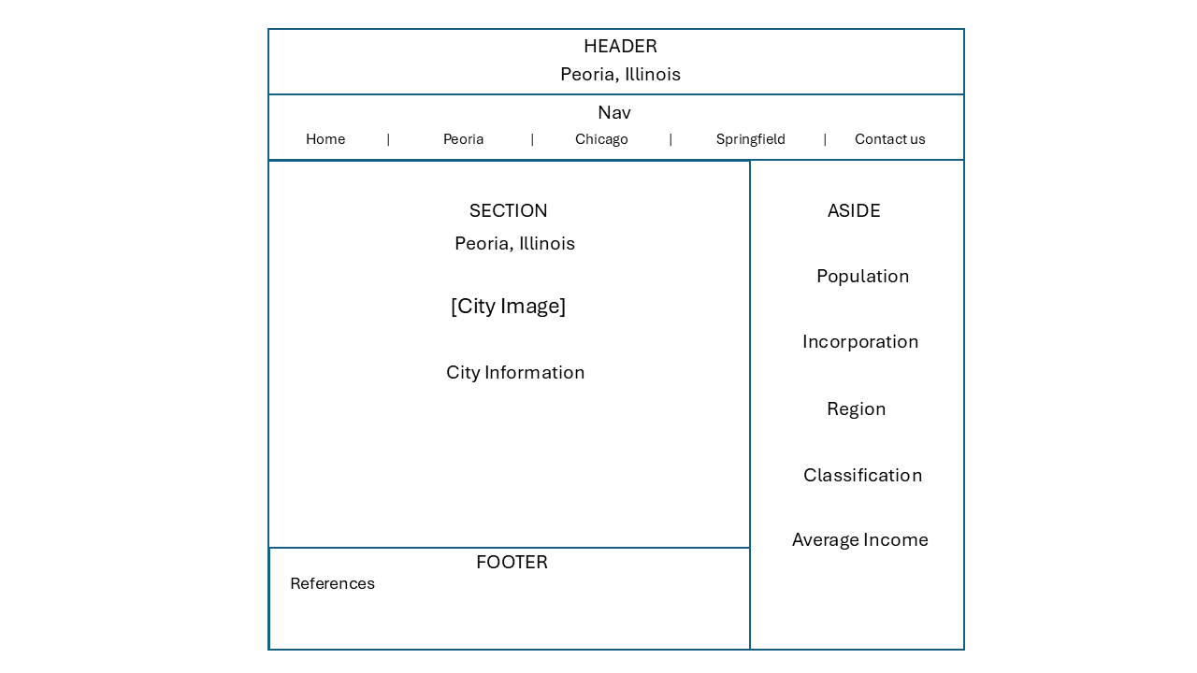

Changes Made to the Home Page:
I had to make a few changes to the Home page that caused it to differ from the original wireframe design submitted for Task 1. The changes were made to ensure the requirements of Task 2 are satisfied.
Added a 5th nav element to allow access to the Contact Us form requirement. This was added to the original Nav bar and location did not change. Adding this element to the Nav bar allows easy access to the Contact Us page no matter which webpage the user is visiting. Added a Footer at the bottom of the page to cite references from images, citations, summaries and quick facts. A table was added to the State introduction section to allow the organization of related data under the constraints of the table requirement.

Changes Made to the Interior City Pages:
I had to make two changes to the Interior City Pages which caused it to differ from the original wireframe design submitted in task 1. Changes were made to ensure continuity between the Home page layout and the Interior pages.
I added a 5th nav element to ensure continuity between each page. This new nav element is a link referring to the contact us page and is located in the Nav bar to allow easy access to the Contact Us page. I also added a Footer containing my references for each city’s facts.

